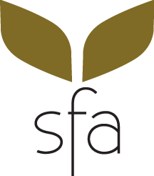
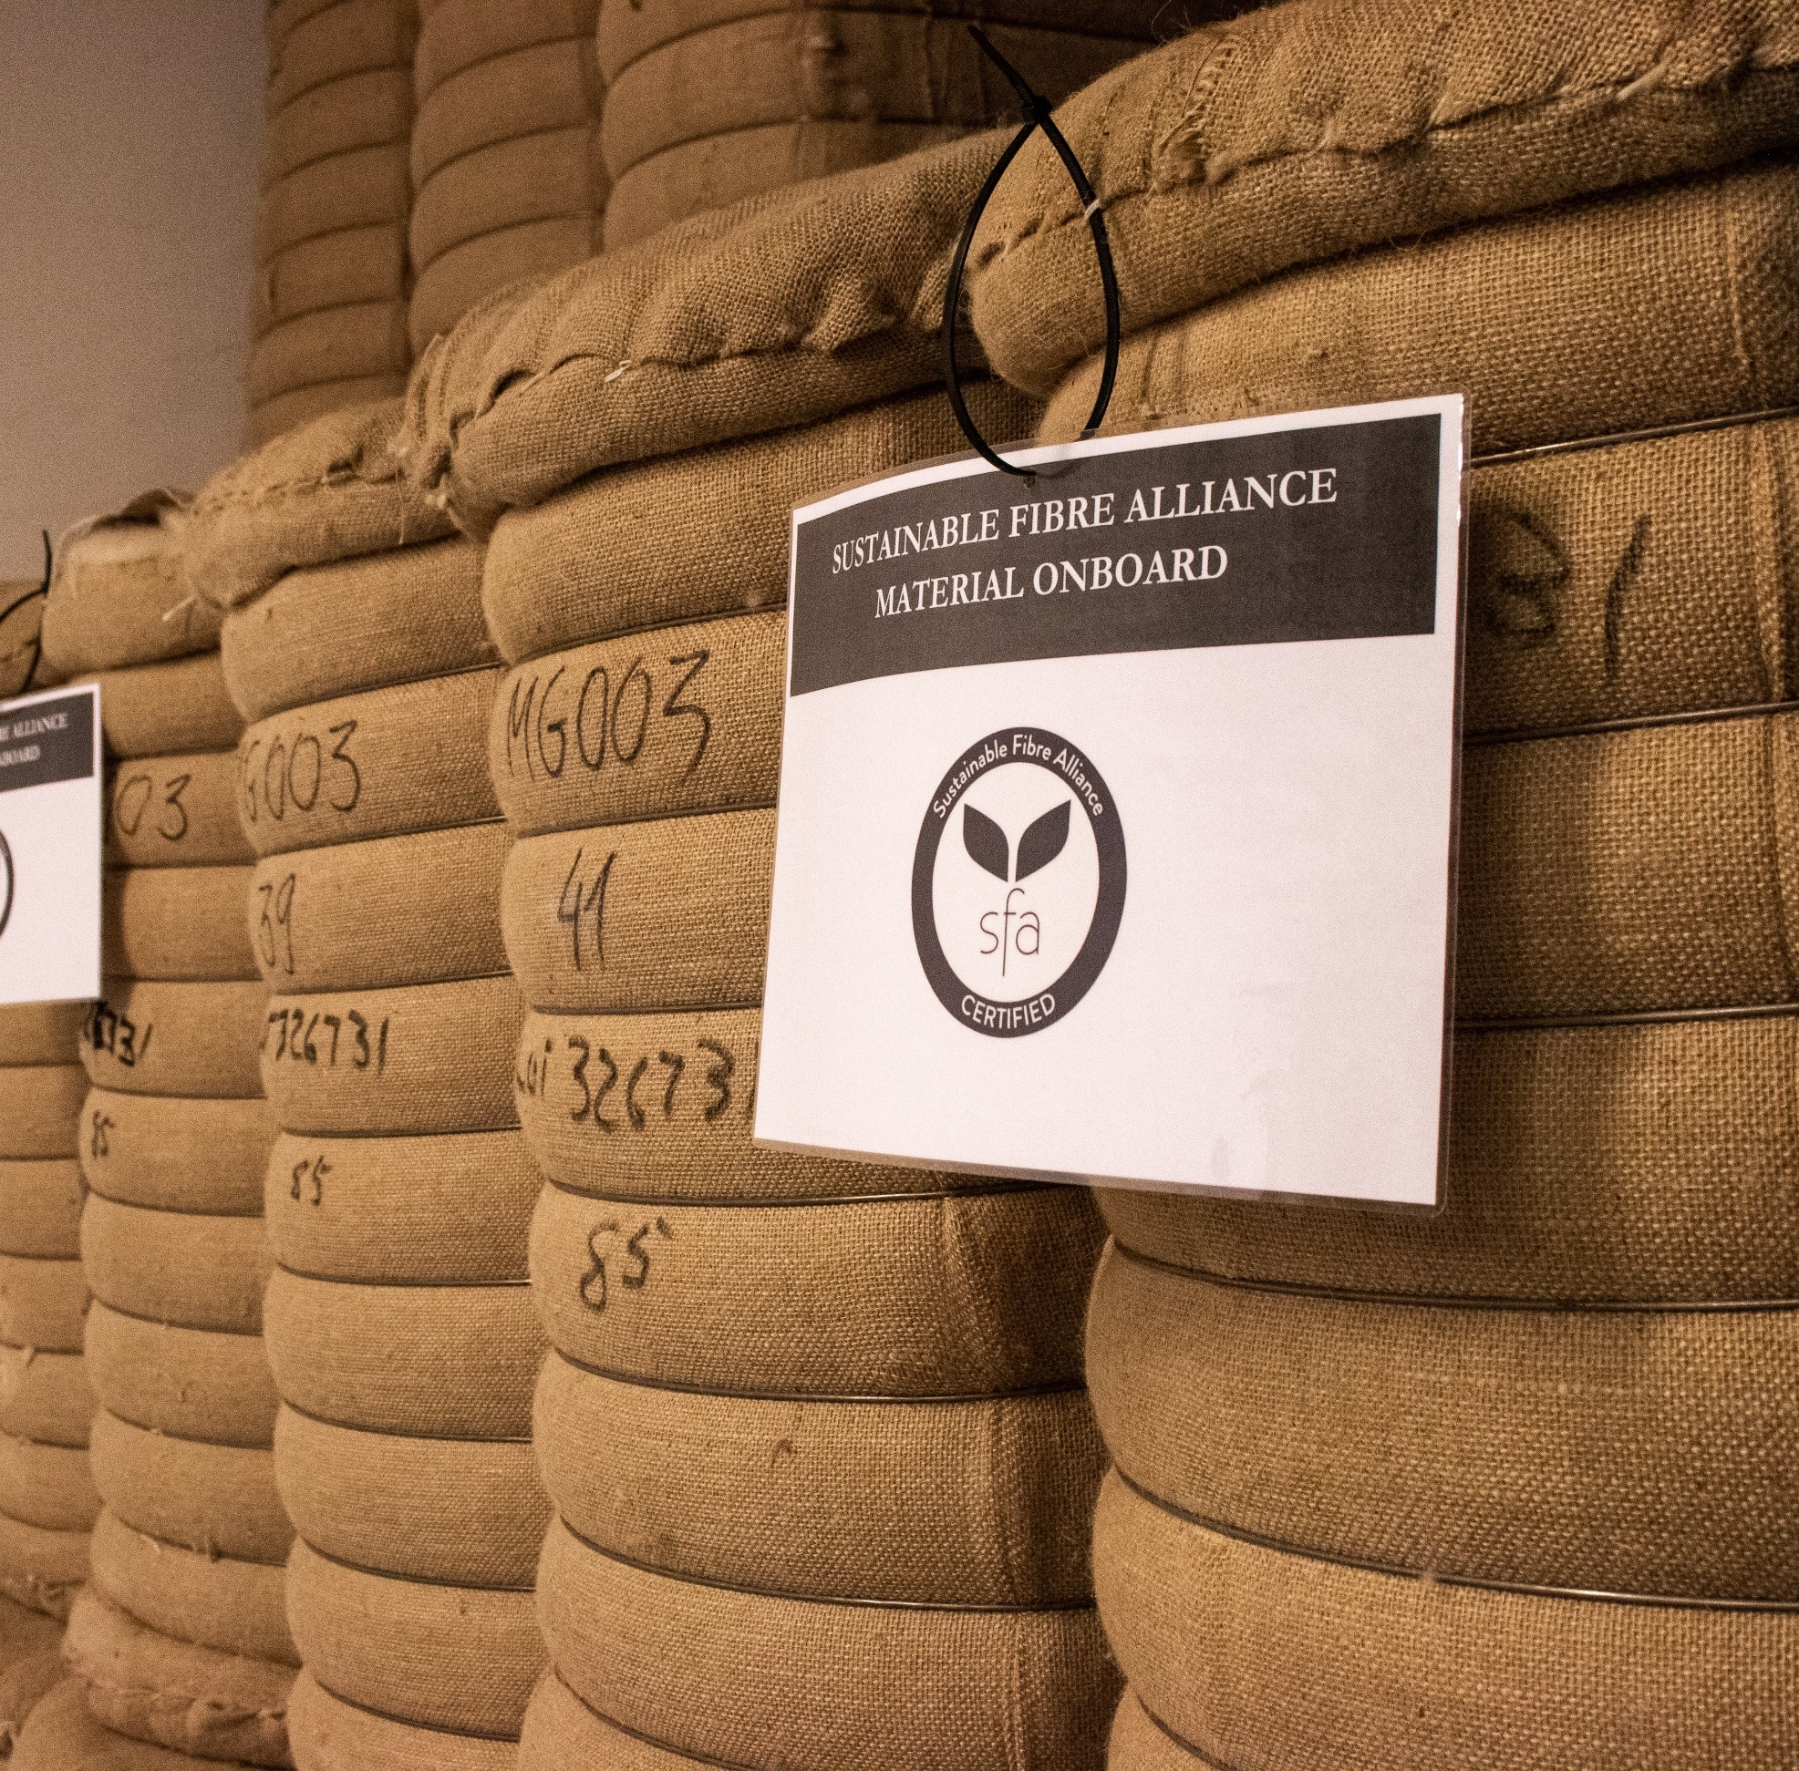
feed
DD Month 20YY [TBC]
SFA Chain of Custody Standard (version 1)

ＳＵＳＴＡＩＮＡＢＬＥ ＦＩＢＲＥ ＡＬＬＩＡＮＣＥ

References
SFA program documents
- Here there will be a link to the SFA Cashmere Standard
- Here there will be a link to the SFA Clean Fibre Processing Standard
- Here there will be links to the SFA Chain of Custody Standard list of tables including:
  - conversion factors
  - recognised equivalent standards
- Here there will be a link to the SFA Visual Brand Guide
- Here there will be a link to the SFA Assurance & Certification Manual
- Here there will be a link to the SFA Glossary
SFA web links
- Here there will be a link to the list of conformity assessment bodies approved to certify against the SFA Chain of Custody Standard
- Here there will be a link to the SFA Certificates Portal
- Here there will be a link to the SFA Transactions Portal
- Here there will be a link to the SFA Standard Setting Procedure.
Effective date
All entities not certified against the Textile Exchange Content Claims Standard or the SFA Chain of Custody Guidelines on DD/MM/YYYY [TBC six months after publication date] who want to make claims regarding the trade of ‘SFA Certified’ products shall be certified against the SFA Chain of Custody Standard (or recognized equivalent shown in Table 1) from DD/MM/YYYY [TBC six months after publication date].
All entities certified against the Textile Exchange Content Claims Standard or the SFA Chain of Custody Guidelines on DD/MM/YYYY [TBC six months after publication date] who are seeking to continue to make claims regarding the trade of ‘SFA Certified’ products shall be certified against the SFA Chain of Custody Standard from the expiry date of their current scope certificate on or after DD/MM/YYYY [TBC six months after publication date].
In this document, the following terms are used to indicate requirements, recommendations, permissions, and possibilities or capabilities:
- “shall” indicates a requirement;
- “should” indicates a recommendation;
- “may” indicates a permission; and
- “can” indicates a possibility or a capability.
- Indicates guidance. Guidance is not normative in and of itself, but may repeat, reinforce and/or clarify normative requirements.

Review of this document
Concerns or comments on the design and/or implementation of this Standard or any other part of the SFA program more broadly should be sent to standards@sustainablefibre.org. All concerns will be considered carefully, no later than when formal review of this document starts within three years of the previous major version being published.
Amendment record
Version | Context | Revision | Date
1.0 | Replacement of SFA Chain of Custody Guidelines v3.1 | To be confirmed. | DD/MM/20YY

CONTENT
References 2
Review of this document 3
CONTENT 4
1. USE OF STANDARD 5
Entities that need certification 5
1.1. Application of other SFA Standards 6
1.2. Exemptions 6
2. MANAGEMENT SYSTEM 7
2.1. Entity structure 7
2.2. Entity legal status 7
2.3. Documented procedures 7
2.4. Resourcing and training 7
2.5. Subcontracting 8
2.6. Monitoring and evaluation 8
2.7. Record keeping 8
2.8. Reporting and transparency 9
3. HANDLING 11
3.1 Processing, storage and transport 11
3.2 Transactions 12
3.3 Quantity reconciliation 13
ANNEX 1: CLAIMS 15

USE OF STANDARD

Entities that need certification
All entities in the cashmere supply chain shall be certified against the SFA Chain of Custody Standard by an approved and accredited third party (i.e. conformity assessment body; CAB) before they may make claims regarding the sale, labelling and/or processing of ‘SFA Certified’ products.
Brands and retailers are not required to be certified if they are only handling finished and SFA labelled products.
Any entity that has a valid and current scope certificate for handling ‘SFA Certified’ products for any of the Standards listed on Table 1 may make claims regarding the sale, labelling and/or processing of ‘SFA Certified’ products, so long as they meet any provisos given in Table 1.
No one, under any circumstances, may copy, reproduce or otherwise use the ‘SFA Certified’ logo without prior written approval from the SFA.
The SFA will publicly pursue all legal means to stop and remedy any unauthorised or misleading use of ‘SFA Certified’ claims or logo.
Table 1: Equivalent Standards recognised by the SFA
Standard | Notes
N/A | N/A
The are currently no other equivalent Standards recognised by the SFA.

Application of other SFA Standards
    - All producer entities seeking to gain or maintain certification against the requirements of this Standard shall be certified against the SFA Cashmere Standard.
    - All primary processor entities seeking to gain or maintain certification against the requirements of this Standard shall be certified against the SFA Clean Fibre Processing Standard.
Products are only ‘SFA Certified’ when the seller is compliant with the requirements of all relevant Standards and/or Codes of Practice.

Exemptions
This section describes how the requirements of the SFA Chain of Custody Standard are applied to entities seeking certification.
    - Entities that do not take physical possession of the ‘SFA Certified’ products they are trading are exempt from the requirements at 4.1 (Processing, storage and transport).
Where a subcontractor has taken physical possession of an ‘SFA Certified’ product on behalf of an entity, the entity is considered to have taken physical possession of that ‘SFA Certified’ product.
Audits of exempt entities can be done remotely.

MANAGEMENT SYSTEM

Entity structure
    - All entities seeking to gain or maintain certification against this Standard shall have a management office.
This does not need to be a physical office.
    - Entities seeking to gain or maintain certification against this Standard may have one or more physical sites where ‘SFA Certified’ products are expected to be physically handled.
Sites may include those operated by subcontractors.

Entity legal status

    - All entities seeking to gain or maintain certification against this Standard shall be a legal entity in the country where its management office is based.
    - The entity shall hold a formal legal relationship with all sites covered by the entity’s scope certificate.
    - The entity shall hold a formal legal relationship with all subcontractors operating on the behalf of the entity.

Documented procedures
    - The entity shall maintain a quality management system that documents processes, procedures, and responsibilities for continuously and consistently meeting each of the requirements of the SFA Chain of Custody Standard.
    - The entity shall have a defined procedure for adding and removing sites from the entity’s scope certificate, including for sites managed by subcontractors.
    - The entity shall have and implement a procedure for the handling of complaints relating to this Standard.
    - The entity shall have procedures in place to ensure that any nonconforming products are identified and controlled to prevent their unintended sale and delivery with SFA claims.

Resourcing and training
    - The entity shall maintain the human and infrastructure resources needed for continuously and consistently meeting each of the requirements of the SFA Chain of Custody Standard.
    - The entity shall appoint a management representative with overall responsibility for meeting the requirements of the SFA Chain of Custody Standard.
      - The entity shall inform the CAB and the SFA of any change in the identity of the management representative within 10 working days.
    - The entity shall identify and define the key personnel responsible for the implementation of each procedure
    - The entity shall ensure that all staff responsible for delivering against one or more of the requirements of the SFA Chain of Custody Standard have adequate training and qualifications for delivering their responsibilities.

Subcontracting
    - The entity shall notify and provide details of the subcontracted activity (name, address, contact details and outsourced activities to be performed) to the CAB before commencing the activity.

Monitoring and evaluation
    - The entity shall annually review their chain of custody management system, including:
- Self-assessment against the requirements of the Standard;
- Action plans for addressing any unresolved issues raised by any party about the entity or any of its sites or products since the last review, including from the most recent self-assessment, with particular reference to any complaints;
- Escalated action plans for addressing any unresolved issues carried over from the last review, with particular reference to any complaints.

Record keeping

    - The entity shall maintain complete, accurate and up-to-date records of the documents covering all aspects of certification requirements.
      - The entity shall ensure that all records are compiled and kept in a database.
This means data shall be stored in a queriable database, not just as scanned electronic copies of hard documents.
    - Records shall be retained for a minimum period of five (5) years.
    - The entity shall keep records of:
- All sites taking physical possession of ‘SFA Certified’ products on behalf of the entity, excluding retail sites;
This includes sites managed and run by subcontractors.
- Subcontractors used, and the activities outsourced to them;
- Transaction Receipts;
- All data related to transactions involving ‘SFA Certified’ products including but not limited to:
  - contracts;
  - product descriptions or specifications including technical parameters;
  - purchase orders;
  - invoices; and
  - shipping and customs documentation.
- All data related to inspections of ‘SFA Certified’ products when they arrive at a site;
- Staff training related to SFA certification;
- Equations and conversion factors used for quantity reconciliation;
- Equations used for content claims where ‘SFA Certified’ cashmere comprises less than 100% of the product;
- Actual conversion factors observed during any processing, detailing the type of processing done and the site where the processing was done;
- The fate of all ‘SFA Certified’ products bought, up to and including when it leaves the ownership and possession of the entity, including:
  - The proportional quantities of that product that is:
    - inventory;
    - was sold as an ‘SFA Certified’ product;
    - sold as an uncertified product;
    - discarded as waste from processing; or
    - otherwise discarded/rejected.
  - The physical location of each proportion with reference to sites where possible;
- Complaints and, for those already resolved, a description of the outcomes including an explanation of how they were resolved;
- Any product quality test data and reports;
- Any claims made on SFA products;
- Anything else recorded to demonstrate conformity with this Standard.
The entity does not need to track onward sales made by a buyer or what happens to waste that has been disposed, beyond what is required by the SFA Clean Fibre Processing Standard.

Reporting and transparency

    - The entity shall provide the SFA and/or the CAB that issued the entity’s scope certificate, and their representatives, unconditional and unsupervised access to all of the entity’s and/or any of the entity’s subcontractors records, sites, and staff related to their scope certificate on request.
    - The entity shall prepare an annual report that demonstrates:
- The quantified fate of all ‘SFA Certified’ products bought during the preceding year, up to when each batch of fibre, if any, up until it leaves the ownership and possession of the entity;
- Entity wide quantity reconciliation quantified to site level for the preceding year, including working out;
- Actual conversion factors observed during any processing;
- The outcomes from any complaints.
- Action plans for addressing unresolved issues, if any.
      - This report shall be shared with the SFA within five working days of being published.
      - Each report shall be published no later than three months after the expiry of their last scope certificate.

HANDLING

Processing, storage and transport
    - The entity shall have procedures in place that control the identification of inputs at all stages of purchasing, raw material storage, production/processing, transport and sales.
    - 100% of the cashmere in any ‘SFA Certified’ product shall be ‘SFA Certified’ cashmere.
‘SFA Certified’ cashmere may be blended with other natural fibres that are not required to be certified.
    - The entity shall not blend ‘SFA Certified’ cashmere with synthetic fibres.
Plating with synthetic fibres is allowed.
    - The entity shall ensure that ‘SFA Certified’ products are kept separate (segregated) from non-certified cashmere products at all times.
This applies to all stages of the supply chain and all processing, including transportation.
    - Entities shall ensure that the identification of material supplied and sold as SFA certified is maintained during storage and all stages of production and handling. The organisation shall implement one or more of the following segregation methods:
- physical separation of materials
- temporal separation of materials
- physical identification of materials (e.g., labelling)
    - The entity shall ensure that any machinery is cleared of uncertified products before use for ‘SFA Certified’ products.
    - The entity shall ensure that ‘SFA Certified’ products are clearly labelled such that they are easily distinguishable from uncertified products at all times.
    - The entity shall ensure that all batches of ‘SFA Certified’ products are labelled such that they can be linked with transaction receipts and all other documentation for that batch.
    - The entity shall ensure that packages of ‘SFA Certified’ products are tamper-proof during transport.

Transactions
    - The entity shall maintain up-to-date information about all suppliers who are supplying materials used for SFA products, which shall cover the following information:
- Name and address of the entity (buyer)
- Name and address of the seller
- Shipment and Delivery date
- Product description or specification
- Quantity of products
- SFA claims
- Document reference (e.g., delivery note or invoice reference)
    - The entity shall only purchase ‘SFA Certified’ products from entities that hold a valid Scope Certificate.
    - The entity shall not purchase ‘SFA Certified’ products without valid Transaction Receipts for the previous sale all of the ‘SFA Certified’ products comprising the products being purchased.
    - The entity shall confirm that all physical ‘SFA Certified’ products received match the details described on the Transaction Receipt for the purchase of that product.
    - Where the entity receives an uncertified product that was sold to the entity as ‘SFA Certified’ product the entity shall inform the CAB and the SFA within five working days.
    - The entity shall ensure that an exact copy of any Transaction Receipt is in the possession of the following before any processing begins for that product:
- the buyer;
- the seller;
- the CAB that issued the buyer’s scope certificate;
- the CAB that issued the seller’s scope certificate; and
- the SFA.
    - The entity shall not sell products as ‘SFA Certified’ unless 100% of the cashmere in the product is ‘SFA Certified’.
    - Where ‘SFA Certified’ cashmere is blended with fibres other than cashmere, the entity shall not sell products as ‘SFA Certified’ unless 100% of the cashmere in the product is ‘SFA Certified’ cashmere and ‘SFA Certified’ cashmere comprises at least 5% of the final product’s composition.
For example, a scarf of 95% wool and 5% cashmere, then this 5% must be ‘SFA Certified’ cashmere. In another example, a scarf of 70% silk and 30% cashmere, then 30% cashmere content must be ‘SFA Certified’ cashmere in the total product.
    - The entity shall not sell dehaired ‘SFA Certified’ products on the open market without written permission from the SFA.
    - The entity shall ensure that any sale of ‘SFA Certified’ products are documented by an electronic Transaction Receipt that has been completed in full.
Transaction Receipts are required every time an ‘SFA Certified’ product is sold. Incomplete Transactions Receipts are invalid.
    - Transaction Receipts shall contain the following information:
- A reference number unique to that transaction;
Unique reference numbers are issued by the SFA.
- Date that the Transaction Receipt was submitted to the SFA;
- The seller’s SFA Chain of Custody Standard scope certificate number;
- The full name of a representative from the seller authorising this transaction;
- The buyer’s SFA Chain of Custody Standard scope certificate number;
- The full name of a representative from the buyer authorising this transaction;
- A list of all sites taking physical possession of the products as part of the transaction;
- A list of preceding Transaction Receipts contributing ‘SFA Certified’ products to this transaction, listing the quantity of product, the site listed on the buyer’s scope certificate at which it was located and any processing already done to it when it before this point.
Technical platform for issuing unique reference numbers and tracking transactions TBC. The platform will involve sellers inputting data to a central database where all data are securely stored and accessible only to the SFA and all CABs.
    - Where any product that cannot be reconciled with the details on the associated Transaction Receipt has already been sold the entity shall inform the CAB, the SFA and the buyer within five working days.
    - The entity shall make claims in accordance with Annex 1: Claims.

Quantity reconciliation
    - The entity shall maintain up-to-date material accounting records that quantify input and output material at site level at all times. It shall cover an ongoing calculation that ensures that the quantity of outputs quantitatively reconciles with the quantity of inputs at all times at a site level, accounting for conversion factors.
Inputs refers to the quantity of the ‘SFA Certified’ products purchased. Outputs include ‘SFA Certified’ product inventory, products sold as ‘SFA Certified’, products sold as uncertified, discarded as waste from processing or otherwise discarded/rejected;
    - The entity shall ensure that the quantity of products sold as ‘SFA Certified’ never exceeds the quantity of ‘SFA Certified’ products bought at a site level, accounting for conversion factors and any conditioning.
    - The entity shall have a consistent methodology for calculating conversion factor(s) and the effects of conditioning, and shall keep them up to date.
    - The entity shall justify any expected conversion factors for any processing done where the type of processing is listed in Table 2.
I.e. at the initial assessment of new entities.
    - The entity shall annually review expected conversion factors, comparing expected conversion factors to the conversion factor actuals observed in the previous year, and justify any changes.
    - The entity shall annually review their methods for calculating the effects of conditioning, accounting for conditioning actuals observed in the previous year, and justify any changes.
    - For each batch of fibre, the entity shall justify any deviations of more than 5% between fibre bought and fibre sold, accounting for conversation factors and conditioning.
      - Accounting for conditioning shall be justified through laboratory data.

Table 2: Processing types for which expected conversion factors need to be agreed with the CAB
 | Type of processing
Harvesting | Shearing
 | Combing
Primary Processing | Sorting
 | Scouring from shorn fibre
 | Dehairing from shorn fibre
 | Scouring from combed fibre
 | Dehairing from combed fibre
Manufacturing | Spinning from woollen
 | Spinning from worsted
 | Weaving
 | Knitting
 | Wet processing
 | Dyeing
 | Final manufacturing
Other | Recycling

ANNEX 1: CLAIMS

- The entity shall only make ‘SFA Certified’ claims that are verifiably accurate.
- The entity shall only make ‘SFA Certified’ claims for products with a valid and traceable Transaction Receipt for the purchase of that product.
- The entity shall not make any ‘SFA Certified’ product claims for any physical products received from a seller that cannot be reconciled with the details described on the Transaction Receipt for the purchase of that product.
- The entity shall only make claims that a product for sale is ‘SFA Certified’ when the entity is selling their own products.
- The entity shall not make claims that do not match the SFA Visual Brands Guidelines.
- The entity shall not make ‘SFA Certified’ claims that make broad environmental, social and animal welfare-based claims.
For example, claims such as ‘ethically produced’, ‘cruelty free’, ‘environmentally friendly’ or ‘100% sustainable’ are not allowed.
- The entity shall not use the SFA logo as a part or the whole of a general claim.
- The entity shall not make claims that a final product for sale is ‘SFA Certified’ without a label which includes the ‘SFA Certified’ Logo, unless otherwise agreed with the CAB.
  - When the ‘SFA Certified’ logo is unable to appear adjacent to the product claim, such as in an online catalogue image, the CAB may approve a text only claim as long as the logo appears elsewhere on the product, hangtag, product listing, or another webpage.
- The entity shall not make other product or content claims made about the product that do not refer to SFA certification in any way that might infer that that claim is associated with being ‘SFA Certified’.
- The entity shall ensure that all product claims include:
- The percentage of ‘SFA Certified’ fibre in the product;
- the name of the entity;
- the entity’s scope number; and
- a reference to the SFA.
- The entity shall not make geographic based ‘SFA Certified’ claims without including the country of origin.
- All on-product claims bearing the ‘SFA Certiﬁed’ logo should include qualifying statements about the SFA to increase consumer understanding and awareness of our work.
- The entity shall not make ‘SFA Certified’ claims without prior approval for that specific claim from the CAB.
A1.13.1 Supplied claims (see Table 3) are exempt from A1.13 and do not need prior approval from the CAB.
A1.13.2 Translated supplied claims do need prior approval from the CAB.
Supplied claims still need to meet all the requirements of this Annex.

Table 3: Supplied claims
General claims | “We source ‘SFA Certified’ cashmere that is traced through the supply chain from certified herders to product.”
 | “Our product range includes cashmere products which have been made with cashmere that has been ‘SFA Certified’.”
 | “[Company/brand] buys ‘SFA Certified’ cashmere as part of our commitment to responsible sourcing.”
 | “By sourcing cashmere that is ‘SFA Certified’, [company/brand] helps to ensure animal welfare and supports the SFA’s work in improving environmental practices and the livelihoods of herders.”
 | “Our ‘SFA Certified’ cashmere is sourced from ‘SFA Certified’ producers and processors.”
 | “[Company/brand] buys ‘SFA Certified’ cashmere as part of our commitment to responsible sourcing.”
 | “Our product range includes cashmere products that have been made with ‘SFA Certified’ cashmere.”
Product claims | “This product is [X%] ‘SFA Certified’ cashmere.”
 | “[X%/All] of the cashmere in this [garment/product] has been produced following high animal welfare practices, as certified by the SFA.”
 | “[X%/All] our cashmere is SFA Certified.”
 | “This [yarn/fabric/product] contains 100% ‘SFA Certified’ fibre.”
Qualifying statements | “The certified cashmere in this garment has been produced in a way that improves the well-being of animals.”
 | “’SFA Certified’ cashmere has been produced to high animal welfare standards, tracing it from herders to final product, and supporting socially responsible practices.”
 | “Purchasing ‘SFA Certified’ cashmere supports the SFA’s work in creating an equitable cashmere supply chain.”
 | “The SFA’s work helps improve the welfare of cashmere goats, the protection of rangelands and security of herder livelihoods.”
 | “The SFA works with herders to improve animal welfare and traces cashmere through to the finished product.”
 | “In buying this product you are supporting the responsible sourcing of cashmere.”
 | “The SFA’s vision is that cashmere is produced in a way that minimises environmental impact, safeguards herder livelihoods and meets high welfare standards.”

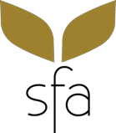

Published by:
Sustainable Fibre Alliance (SFA)
For more information, please visit http://sustainablefibre.org or contact info@sustainablefibre.org

